# SUPPLEMENT

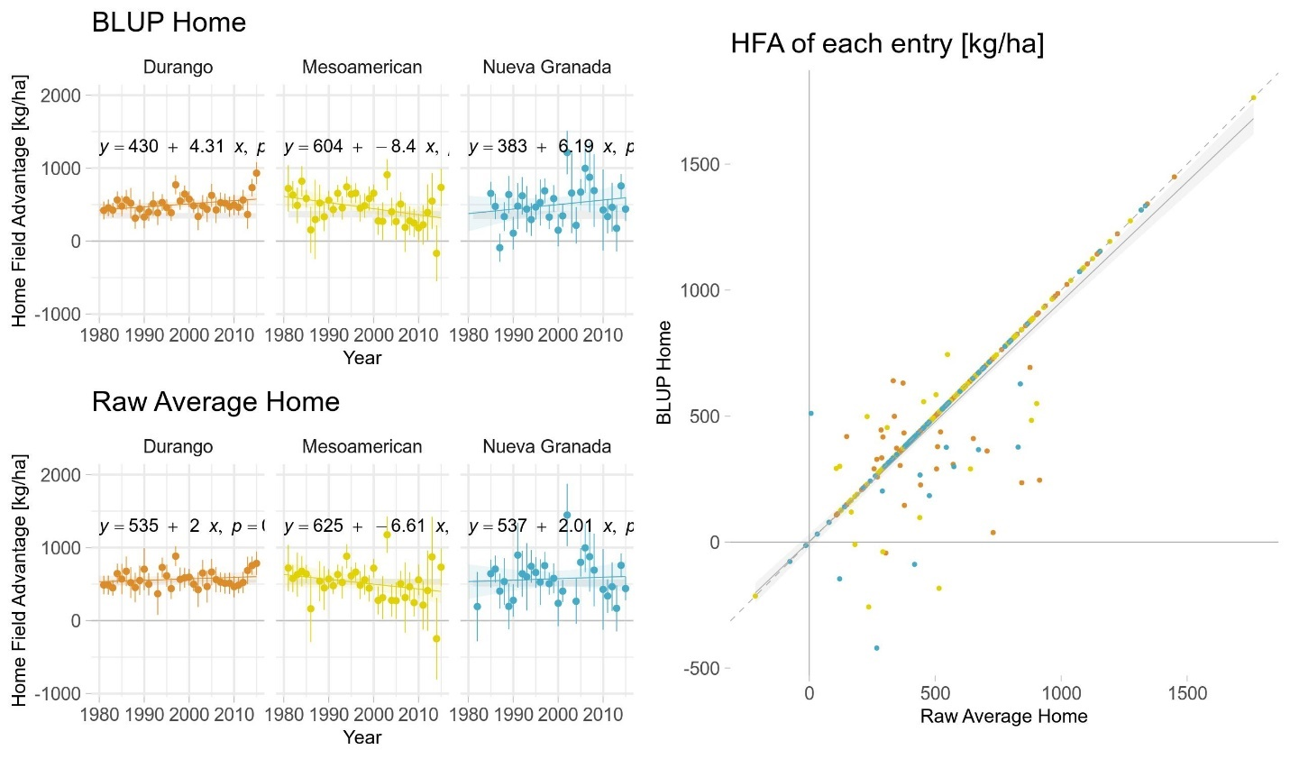

**Figure S1:** Comparison of BLUP (this manuscript) and average performance (Ewing et al, 2019) methods of identifying home sites. The top two panels recreate Figure 2b; note reduced variance, lower observed HFA, and lower expected HFA (grey horizontal bar) in the BLUP versus the raw average method. The bottom panel shows entry-level HFA comparing the methods, with symbology as in Figure S4c; the dashed diagonal line is a 1:1 relationship. 75% of home site assignments were identical among entries.

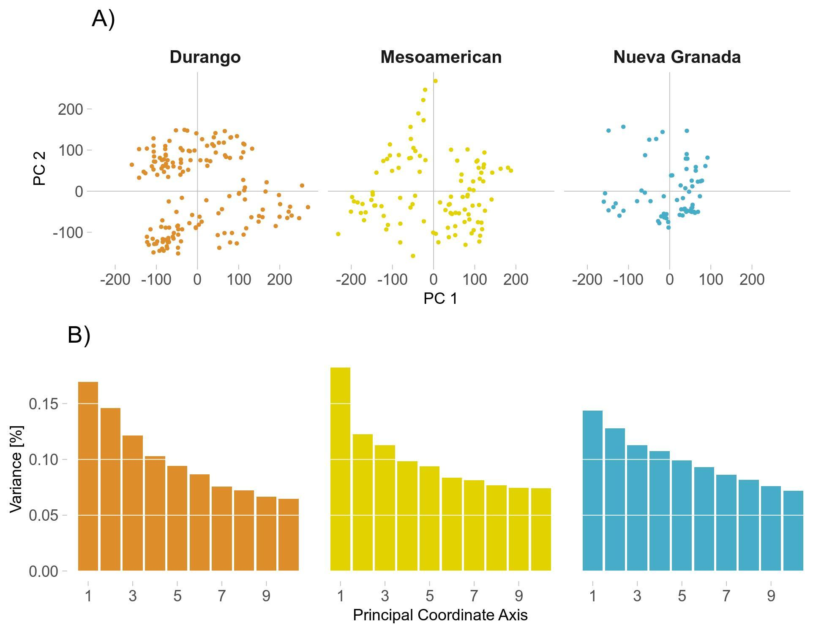**Figure S2**: Summary of kinship among varieties within race. A) ordination of varieties along principal component axes 1 and 2. B) Scree plot of variance explained by successive principal axes.

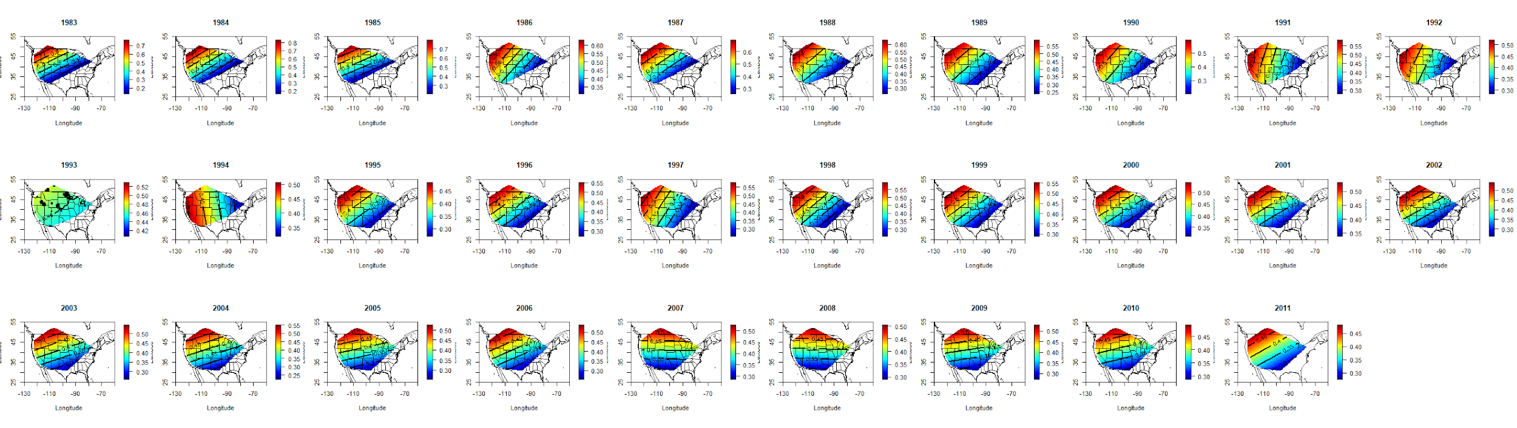**Figure S3.** Ordinary kriging of yield heritability for each 5-year sliding window (1981-2013) centered on the third year of the window.

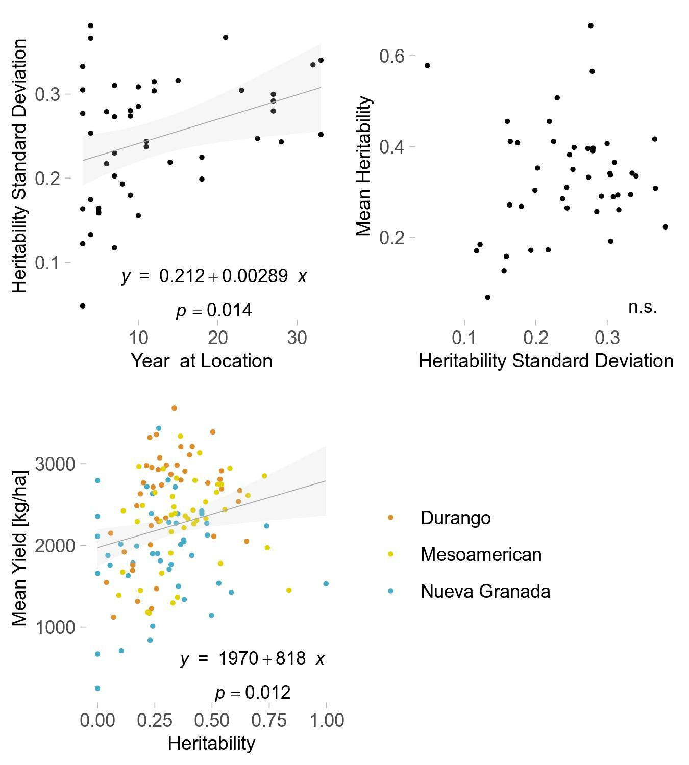

**Figure S4**: a) relationship between standard deviation in heritability at each site, and the number of trials at that site; b) relationship between mean and standard deviation in heritability at each site; c) relationship between mean yield and mean heritability at each site. n.s. – not significant at p < 0.10.

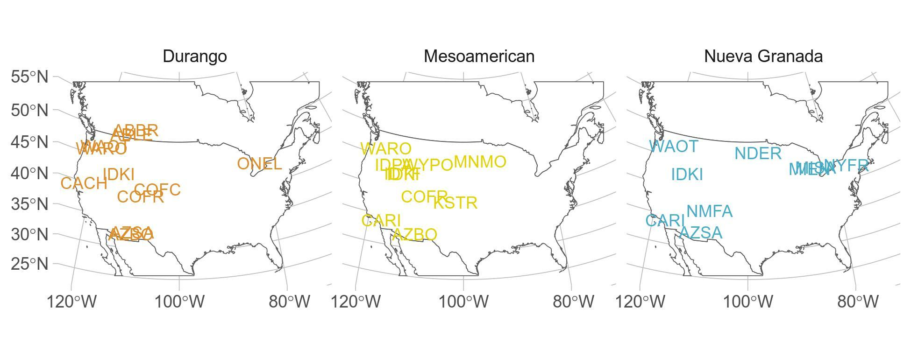**Figure S5**. High heritability and high HFA location combinations by bean race. Abbreviations correspond to CDBN standard abbreviations.

|  |  |
| --- | --- |
| **Table S1** | |
| Terms of models partitioning yield variance | |
| **Model** | **Terms** |
| 1 | Site; year; site-by-year; entry |
| 2 | Site; year; site-by-year; entry; home site indicator |
| 3 | Site; year; site-by-year; entry; kinship PCA axes 1-3 |
| 4 | Site; year; site-by-year; entry; home site indicator; kinship PCA axes 1-3; home site-by-kinship axes |

|  |  |  |  |  |
| --- | --- | --- | --- | --- |
| **Table S2** | | | | |
| ANOVA of Yield Across Time | | | | |
|  | **Sum Sq** | **Df** | **F value** | **Pr(>F)** |
| **Year** | 252,500,000 | 1 | 292.70 | 0.000 |
| **Race** | 1,050,000,000 | 2 | 608.26 | 0.000 |
| **Year*Race** | 6,895,000 | 2 | 4.00 | 0.018 |
| **Residuals** | 11,370,000,000 | 13174 | - | - |

|  |  |  |  |
| --- | --- | --- | --- |
| **Table S3** | | | |
| AIC1 of Competing Home Field Advantage Models | | | |
|  | **Durango** | **Mesoamerican** | **Nueva Granada** |
| **With Home Field** | 6772 | 5095 | 3434 |
| **Base (Variety, Site, Year)** | 7323 | 5421 | 3599 |
| **With Home Field, Kinship** | 7662 | 5703 | 3773 |
| **With Kinship** | 8143 | 5997 | 3926 |
| 1Akaike Information Criterion | | | |

|  |  |  |  |  |
| --- | --- | --- | --- | --- |
| **Table S4** | | | | |
| ANOVA of Home Field Advantage Across Time | | | | |
|  | **Sum Sq** | **Df** | **F value** | **Pr(>F)** |
| **Year** | 4.755 | 1 | 0.00 | 0.992 |
| **Race** | 36,290 | 2 | 0.43 | 0.654 |
| **Year * Race** | 410,000 | 2 | 4.82 | 0.010 |
| **Residuals** | 3,994,000 | 94 | - | - |

|  |  |  |  |  |  |  |  |
| --- | --- | --- | --- | --- | --- | --- | --- |
| **Table S5** |  |  |  |  |  |  |  |
| Genome-wide nucleotide diversity measures on 1.22M SNPs segregating in the CDBN. | | | | | | | |
| **Race** | **Five Year Window End** | **Sample Size** | **25% Quantile** | **Median** | **75% Quantile** | **Variance** | **SE** |
| Durango | 1985 | 37 | 0.029 | 0.189 | 0.389 | 0.0338 | 0.0302 |
| Durango | 1990 | 21 | 0.000 | 0.203 | 0.398 | 0.0358 | 0.0413 |
| Durango | 1995 | 27 | 0.073 | 0.230 | 0.409 | 0.0332 | 0.0351 |
| Durango | 2000 | 34 | 0.082 | 0.249 | 0.419 | 0.0320 | 0.0307 |
| Durango | 2005 | 38 | 0.081 | 0.238 | 0.413 | 0.0315 | 0.0288 |
| Durango | 2010 | 23 | 0.059 | 0.246 | 0.426 | 0.0348 | 0.0389 |
| Durango | 2015 | 30 | 0.078 | 0.239 | 0.418 | 0.0329 | 0.0331 |
| Mesoamerican | 1985 | 19 | 0.000 | 0.233 | 0.425 | 0.0375 | 0.0444 |
| Mesoamerican | 1990 | 15 | 0.000 | 0.228 | 0.429 | 0.0414 | 0.0526 |
| Mesoamerican | 1995 | 37 | 0.073 | 0.239 | 0.416 | 0.0327 | 0.0297 |
| Mesoamerican | 2000 | 28 | 0.056 | 0.233 | 0.416 | 0.0344 | 0.0351 |
| Mesoamerican | 2005 | 18 | 0.000 | 0.214 | 0.416 | 0.0356 | 0.0444 |
| Mesoamerican | 2010 | 13 | 0.000 | 0.159 | 0.409 | 0.0422 | 0.0570 |
| Mesoamerican | 2015 | 5 | 0.000 | 0.000 | 0.429 | 0.0554 | 0.1053 |
| Nueva Granada | 1985 | 5 | 0.000 | 0.000 | 0.000 | 0.0308 | 0.0785 |
| Nueva Granada | 1990 | 8 | 0.000 | 0.000 | 0.000 | 0.0325 | 0.0637 |
| Nueva Granada | 1995 | 10 | 0.000 | 0.000 | 0.209 | 0.0363 | 0.0603 |
| Nueva Granada | 2000 | 9 | 0.000 | 0.000 | 0.143 | 0.0360 | 0.0633 |
| Nueva Granada | 2005 | 16 | 0.000 | 0.000 | 0.186 | 0.0318 | 0.0446 |
| Nueva Granada | 2010 | 3 | 0.000 | 0.000 | 0.000 | 0.0317 | 0.1028 |
| Nueva Granada | 2015 | 10 | 0.000 | 0.000 | 0.233 | 0.0358 | 0.0598 |